Exploring the In vivo Antiangiogenic Activity via CAM Assay and In vitro Cytotoxic Effects of Iraqi cultivated Leonotis leonurus Methanol Leaf Extract Against A2780 Human Ovarian Cancer Cells
ELAF B. Dawood ^{*,1} and Dhuha A.ALShammaa¹
¹Department of Pharmacognosy and Medicinal Plants, College of Pharmacy, University of Baghdad, Iraq
Received 30/3/2025, Accepted 14/10/2025, Published 24/6/2026

This work is licensed under a Creative Commons Attribution 4.0 International License.

Abstract
This study investigated the in vivo antiangiogenic activity and in vitro cytotoxic effects of the methanol leaf extract from Leonotis leonurus (Lamiaceae), a commercially important plant in traditional medicine known as "wild dagga" or "lion’s ear," against A2780 human ovarian cancer cells. The therapeutic potential of the plant is attributed to its phytochemicals, secondary metabolites that protect against infections and environmental stress.
The Antiangiogenic activity was assessed using the avian chorioallantoic membrane (CAM) assay, where the extract was applied at 500 mg/mL and observed for blood vessel inhibition after 48 hours. Cytotoxicity was evaluated via the MTT assay on A2780 cells treated with extract concentrations ranging from 31.25 to 1000 µg/mL for 72 hours, with cell viability quantified by optical density at 492 nm. Phytochemical profiling was performed using reverse-phase high-performance liquid chromatography (RP-HPLC) with standards for identification and quantification. Statistical significance was determined by one-way ANOVA followed by Tukey's multiple comparisons test (p < 0.05). The CAM assay demonstrated 100% inhibition of blood vessel growth at 500 mg/mL compared to controls. The MTT assay revealed dose-dependent cytotoxicity, with an IC50 value of 93.22 µg/mL and cytotoxicity percentages ranging from 14% at 31.25 µg/mL to 69% at 1000 µg/mL; significant reductions in optical density (p < 0.05) were observed at all concentrations. RP-HPLC identified high levels of phenolic acids, stilbene and flavonoid, including resveratrol (665.4 ppm; novel detection in this plant), chlorogenic acid (342.7 ppm), apigenin (280.2 ppm), and caffeic acid (106.11 ppm), which are associated with angiogenesis suppression and apoptosis induction. These findings position L. leonurus as a promising natural source of bioactive compounds with antiangiogenic and cytotoxic properties, warranting further research for anticancer drug development.
Keywords: Leonotis leonurus; antiangiogenic activity; cytotoxicity; CAM assay; ovarian cancer; phenolic compounds; resveratrol; chlorogenic acid.

Introduction
Herbal medicines persist in garnering significant interest from researchers and the public, particularly in non-industrialized nations ⁽¹⁾. These therapies have been employed to address diverse disorders or to mitigate symptoms linked to numerous diseases. The therapeutic efficacy of a plant is largely dependent upon the presence of phytochemicals which are secondary metabolites synthesized by plants. These phytoconstituents contribute to a plant’s fragrance, pigmentation, and taste while also protecting against infections and environmental stressors ⁽²⁾. Medicinal plants have therapeutic characteristics that have led to an increase in research to study the activity of secondary metabolites as alternative drugs that may be less harmful than synthetic drugs. Leonotis

leonurus (L. leonurus), a member of the Lamiaceae family and commonly referred to as "wild dagga," or “lion’s ear” ⁽³⁾. L. leonurus is an evergreen herb native to South Africa and Swaziland's cultivated fields and grasslands ⁽⁴⁾. L. leonurus is a commercially important medicinal plant renowned for its extensive traditional uses in treating a wide range of ailments, including bacterial infections, arthritis, cardiovascular diseases, viral infections, diabetes mellitus, inflammation, coughs, diarrhea, dysentery, dyspepsia, fever, headaches, jaundice, renal diseases, colic, hepatitis, rheumatism, and as a sedative or central nervous system depressant ^{(5,6)}. The infusions that are prepared from the leaves, roots, or stems are used frequently as medicinal remedies. The roots have a significant role in the
treatment of ringworm and skin ailments. While the volatile oils, flavonoids, terpenoids, and polyphenolics which have been found in the leaves play a significant role in the treatment of illnesses ⁽⁷⁾, thus L. leonurus may provide phytoconstituents that contribute to the treatment of numerous health problems. Several phytochemical classes have been detected in the plant, such as diterpene, with specific example including marrubiin. Other notable compounds found in L. leonurus are terpenoids like trans-β-ocimene, cis-β-ocimene, β-caryophyllene, caryophyllene oxide, α-humulene, γ-elemene, α-cubebene, and germacrene D. Additionally, phenolic acids such as caffeic acid and chlorogenic acid, along with the flavonoid apigenin, have also been identified ^{(8, 9)}.
Given the potential of natural sources for treating diseases, a crucial area of focus is Angiogenesis, the process by which new capillaries arise from an existing vascular network, vital for numerous physiological and pathological conditions such as embryogenesis, tumor growth and metastasis, rheumatoid arthritis, diabetes, and atherosclerosis. In tumors, it represents the key event to satisfy the increasing demand for nutrients and waste product elimination and sustain malignant cell proliferation, eventually promoting local invasion and metastasis ⁽¹⁰⁾. For this reason, a broad range of antiangiogenic strategies have now become established as a successful clinical approach to alleviate chronic inflammatory conditions and to restrict cancer development and dissemination by preventing the tumor from being fed ⁽¹¹⁾. Plentiful synthetic and natural angiogenesis inhibitors have been reported to act against angiogenesis through different mechanisms of action, but they showed limited efficacy and significant systemic side effects ⁽¹²⁾. Consequently, in the last decade, the interest in discovering antiangiogenetic molecules from natural sources, such as medicinal plant extracts, which generally possess multiple anti-cancer effects, has gained importance for developing more effective and safer anti-cancer treatments ⁽¹³⁾.
The Avian chorioallantoic membrane (CAM) assay allows for a rapid, cost-effective method for studying angiogenesis ex vivo. It also provides additional benefits, such as many embryos readily available for experiments and low maintenance requirements ⁽¹⁴⁾. Due to the organotypic nature of the CAM, this assay accounts for cellular as well as tissue-scale biological responses to the tested drugs or compounds. There is also a reduced risk of false-positive readouts as it provides quantitative 2D and, to a greater extent, 3D data of both the local microenvironment and the angiogenic response of the embryo to pro- and antiangiogenic compounds ⁽¹⁵⁾. The search for novel compounds that may prevent or slow the uncontrolled pooling of tumor-derived blood vessels and the blockage of the nutrient supply to rapidly dividing cancer cells is of paramount importance. The rapidly expanding poly pharmacopeia has, however, not been satisfactorily addressed by the available commercial antiangiogenic drugs. The Avian chorioallantoic membrane CAM is a valuable system that affords a model for the rapid screening and evaluation of the antiangiogenic potential of plant extracts, fractions, and metabolites for the production of smaller and safer dietary supplements or new chemical entities, with well-defined mechanisms of action ⁽¹⁶⁾.
To date, there has been limited research on the anti-angiogenic and cytotoxic effects of L. leonurus. The present study investigates whether L. leonurus extracts possess antiangiogenic properties in an in-vivo CAM model. Additionally, the study aims to assess the cytotoxic effect of L. leonurus methanol leaf extract against A2780 Human Ovarian Malignant Cells.

Materials and Methods
Plant Materials
The leaves of L. leonurus were collected in April 2024. The species was authenticated by Assistant Professor Dr. Sukaina Abbas from the Department of Biology, College of Science, University of Baghdad. The identification was confirmed with the voucher specimen number 623.
Extraction
The leaves were harvested from Babil City. The plant material was subjected to air drying in a shaded and well-ventilated environment. The desiccated leaves were then pulverized into a fine powder. A total of 250 grams of the dried leaf powder underwent extraction via a sequential Soxhlet extraction methodology. Initially, 100 grams of powdered leaves were extracted with 1000 milliliters of n-hexane at 40 °C. Subsequently, the resultant extract was refined and concentrated using a rotary evaporator, after which the plant residue was dried to facilitate further extraction with alternative solvents. This procedure was iteratively applied with 1000 milliliters for every 100 grams using dichloromethane, methanol, and water in that order ^{(17, 18).} Only the methanol extract with the accepted yield has been deposited at the College of Medicine, Al Nahrian University, Baghdad, Iraq, for antiangiogenic study and Cell Tech Lab, Harthyia, Baghdad, for cytotoxic assessment.
CAM Assay
Avian chorioallantoic membrane (CAM) was conducted According to the Lokman’s method ⁽¹⁹⁾ utilizing fertilised chick eggs procured from the Ebaa Research Centre in Baghdad, Iraq. Then, they were maintained in a controlled saturated incubator at a consistent relative moisture of 60% and a temperature of 37°C for 72 hours, during which the eggs were oriented in a horizontal alignment. On day four (D4), a minute perforation was accomplished at the blunt end of the egg of the eggs, followed by the taking out of 2-3 ml of albumin, which was subsequently wrapped to facilitate the descent of the embryo and the chorioallantoic membrane (CAM) for enhanced imagining of the developed CAM, wherein the CAM would detach from the sac that is affixed to the eggshell. The eggs were exposed to an additional incubation period of 24 hours. On D5, a modest square window (3-4 cm) was created in the shell, and the sample was prepared at a concentration of 500 mg/mL. 20 µl placed on the test specimens, previously immersed in circular filter paper discs, were positioned on the CAM, with the aperture subsequently sealed using a sterile surgical adhesive tape to guarantee sterility and preserve humidity. The antiangiogenic capacity was then evaluated. The methanol extract was applied at concentrations (500 mg/mL), and the effects on blood vessel growth were observed. Inhibition of vessel growth was determined by visual scoring under a stereomicroscope, where 100% inhibition was defined as the complete absence of new vessel formation within the observation field, with no vessels extending toward the treatment site. After 48 hours, blood vessel inhibition was quantified and compared to untreated controls ⁽¹⁹⁾. This procedure has been triplicated to ensure the accuracy of results.
Cytotoxicity Assay (MTT)
To assess the cytotoxic properties of the methanol extract derived from the foliar components of L. leonurus. The A2780 human ovarian cancer cell line was obtained from the American Type Culture Collection (ATCC). The cell line was authenticated by short tandem repeat (STR) profiling and was regularly tested for mycoplasma contamination to ensure the integrity of the experiments. The W1 ovarian malignant human cell line was derived from the tumor tissue to a patient didn’t receive any treatments and diagnosed with serous ovarian adenocarcinoma ⁽²⁰⁾. The cell lines were grownup in MEM (US Biological, USA) augmented with 10% (v/v) fetal bovine serum (FBS) (Capricorn-Scientific, Germany), accompanied by 100 IU of penicillin and 100 µg of streptomycin (Capricorn-Scientific, Germany), and raised in a moistened environment at 37 °C. Exponentially multiplying cells were employed for the tests ⁽²¹⁾.
The multiplying cells were inoculated at a mass of 10,000 cells in a 96-well microplate (NEST Biotech, China). Then incubated at 37 °C for seventy-two hours until monolayer convergence was attained. Cytotoxicity was explored through 3-(4,5-dimethylthiazol-2-yl)-2,5-diphenyltetrazolium bromide (MTT) assay (Elabscience, China). The cells were treated with a variety of concentrations (1000, 500, 250, 125, 62.5, 31.2 ug). After seventy-two hours of contagion, MTT dye solution 28 µL of (2 mg/ml) was supplemented to every well. The dwelling sustained for three hours. 100 μl of DMSO was supplemented separately to every well and cultured for fifteen minutes. The optical density was counted at 492 nm using a microplate reader. At that point, the Cytotoxicity percent was considered using the subsequent equation:
“Cytotoxicity % = (OD Control – OD sample)/OD Control × 100”,
OD control is the mean optical density of untreated wells, and OD Sample is the optical density of treated wells. ⁽²²⁾
Statistical Analysis
Data were evaluated using Tukey's multiple comparisons test GraphPad Prism version 8.0 (GraphPad Software, Inc., San Diego, CA, USA). Results were expressed as the mean ± standard error of the mean (SEM). Statistical significance was determined using one-way ANOVA followed by Tukey's multiple comparisons test, with a value of p < 0.05 considered significant. ⁽²³⁾ The values were presented as the mean ± SD of triplicate measurements ⁽²⁴⁾.
Quantitative evaluation and qualitative profiling of Phenolic acids and Flavonoid Compounds by reverse phase HPLC
Phytochemical profiling was conducted in the Environmental and Water Research Department of the Ministry of Science and Technology using a reversed-phase C18 HPLC column (ODS C18, 5 µm, 250 mm × 4.6 mm) on a SYKAM chromatographer (Germany) equipped with a diode array detector (DAD).
The HPLC conditions existing in the table were used to isolate and calculate phenolic acids and flavonoids in plant extracts (table 1) ⁽²⁵⁾⁽²⁶⁾. The qualitative and quantitative analysis of phytochemicals was performed using a reversed-phase HPLC system. The reference standards for resveratrol (purity 98%), and chlorogenic acid (purity 98%) were purchased from Chengdu Biopurify Phytochemicals Ltd. (Chengdu, China). Caffeic acid (purity 98%) was purchased from Macklin (Shanghai, China). Apigenin (purity 98%) was purchased from Bidepharm (Shanghai, China). The Retention times of compounds were established by comparison with standards retention time (chlorogenic acid, caffeic acid, apigenin and resveratrol).

Table 1. Illustrate the condition used for RP HPLC.
Category | Parameter
The mobile phase | Solvent A: 1% formic acid in water  Solvent B: Acetonitrile
The Gradient elution | 0–4 minute: 10% → 15% B. 5–8 minute  15% → 30% B.9–15 minute: 30% B (isocratic)
The Conditions | Flow rate: 1 mL/min  Injection volume: 100 µL  Column temperature: 40°C
Modified condition | Column temperature: 25°C  Wavelength detection 307 nm  Flow rate: 0.9 mL/min
Detection wavelengths | 254 nm (phenolic acids) and 277 nm (flavonoids)

Result and Discussion
CAM Assay
The methanol extracts of L. Leonurus suppressed the angiogenesis by 100% at 500

mg/mL dose (see Figures.1).

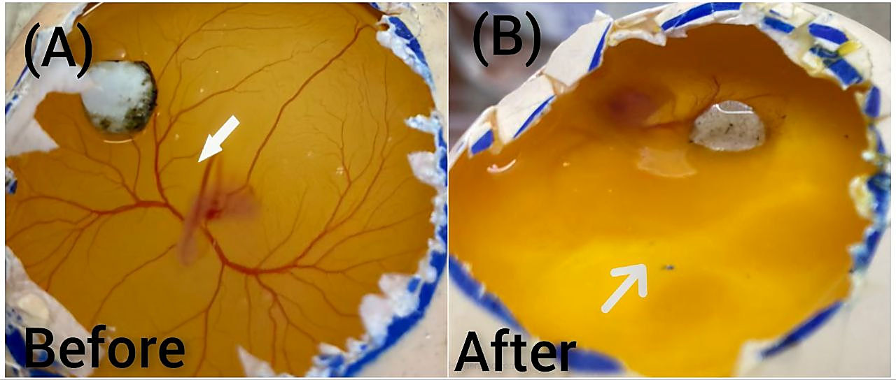
Figure 1. In vivo CAM assay: (A) Negative control treated with distilled water, showing normal blood vessel growth and branching patterns on the chorioallantoic membrane. (B) Treated with methanol extract of L. leonurus at 500 mg/mL, demonstrating complete (100%) inhibition of blood vessel formation, with no visible new vasculature or branching compared to the control. Images captured after 48 hours of treatment.

Cytotoxicity of L. Leonurus methanolic leaves extract
This cytotoxicity assay evaluates the potentially toxic effects of L. leonurus methanolic leaf extract on malignant cell lines. By assessing the viability of the cells in response to various concentrations of the test compound.
The methanolic leaf extract Manifested a dose-dependent reduction in the cytotoxicity. As the concentration of the extract increased, the percentage of cytotoxicity increased significantly. At the highest concentration tested (1000 µg/mL), the rate of cytotoxicity increased to 69%, indicating strong cytotoxic effects. At lower concentrations (31.25 µg/mL), the percentage of cytotoxicity dropped to 14%, suggesting reduced cytotoxicity at lower doses (Figure.2).
The IC50 value, which depicts the concentration of the extract required to kill 50% of cell viability, was calculated to be 93.22 µg/mL, suggesting that the methanolic extract of L. Leonurus has potent cytotoxic effects against A2780 ovarian cancer cells (Figure.3) and the optical density (OD) readings at 492 nm were used to quantify cell viability. The methanol extract demonstrated significant optical density (p<0.05) against the human ovarian cancer cell line in the MTT assay across all five tested concentrations, with a more pronounced effect at the highest concentration (1000 µg/mL). The OD values decreased with increasing extract concentrations, confirming the reduction in viable cells (Figure.4). A2780 cell Morphology was observed previous to treatment and subsequent to treatment with L. Leonurus leaves methanol extract (Figure.5).

Figure 2. Inhibitory curve showing the effect of L. leonurus on cell viability. The horizontal axis represents the concentration of the test compound (in µg/mL), and the vertical axis represents the percentage of cell death (Cytotoxicity %; mean ± SD, n=3). Data points represent concentrations: 31.25, 62.5, 125, 250, 500, and 1000 µg/mL.

Figure 3. Dose-response curve used to determine the IC50 value of L. leonurus extract on cancer cells. The horizontal axis represents the log concentration of the test compound (in µg/mL), and the vertical axis represents the percentage of cell inhibition (mean ± SD, n=3). The IC50 value is indicated by a dashed line at 50% inhibition, corresponding to 93.22 µg/mL.
Figure 4. Optical density (OD) reading curve for cells treated with L. leonurus extract. The horizontal axis represents concentrations in µg/mL (31.25, 62.5, 125, 250, 500, 1000), and the vertical axis represents the OD value at 492 nm (mean ± SD, n=3). * Indicates p < 0.05, p < 0.01, * p < 0.001 compared to control (Tukey's test). Units: absorbance (AU).

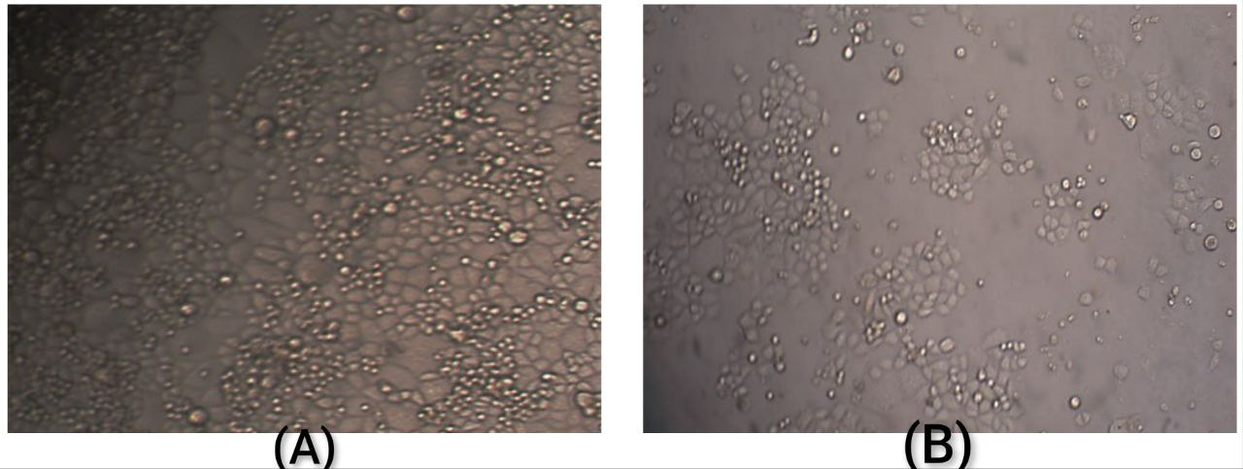
Figure 5. Morphology of A2780 cells: (A) Previous to treatment, showing confluent monolayer of adherent cells with typical spindle-shaped morphology. (B) Subsequent to treatment with L. leonurus methanol extract at 1000 µg/mL for 72 hours, displaying rounded, detached cells indicative of cytotoxicity and apoptosis. Images captured under phase-contrast microscopy; scale bar = 50 µm.

Quantitative evaluation and qualitative profiling of Phenolic acids and Flavonoid Compounds by reverse phase HPLC
The qualitative analysis of phenolic acids, flavonoids, and other bioactive compounds in the methanolic extract of Leonotis leonurus leaves was conducted using reversed-phase high-performance liquid chromatography (RP-HPLC) ⁽²⁷⁾. The recognition of these compounds was achieved by comparing their retention times with those of authentic standards, including caffeic acid, chlorogenic acid, luteolin, apigenin, and resveratrol, under identical chromatographic conditions. The Qualitative confirmation of phenolic acids (caffeic acid and chlorogenic acid), stilbene (resveratrol) and flavonoid (apigenin) were achieved in the methanolic extract by RP-HPLC analysis. As depicted in the figures, the retention period recorded for the compounds in the extract identical retention time with those of their corresponding standards, confirming their identity (see figures6, 7, 8, 9,10 and 11).
For quantitative analysis, a calibration plot was established using a series of diluted solutions prepared from a stock solution of each of the standards. The values of caffeic acid, chlorogenic acid, luteolin, apigenin and resveratrol concentrations in the Leonotis leonurus methanolic extract were calculated through data from a linear regression equation taken from the calibration plot. The equation was obtained by plotting the concentration of each standard against the matching peak area under the curve (see Figures12,13,14 and 15).
The methanolic extract of L. leonurus had high concentrations of phenolic acids (caffeic acid and chlorogenic acid), stilbene (resveratrol) and flavonoid (apigenin), as determined by the results. In particular, rise to the highest concentration includes 665.4 ppm of resveratrol, 342.7 ppm of chlorogenic acid, 280.2 ppm of apigenin, and 106.11 ppm of caffeic acid with their corresponding retention time (3.99 minute and 5.32 minute) for phenolic acids while for flavonoid and stilbene (10.20 minute and 4.99 minute). These findings align with previous studies reporting caffeic acid, chlorogenic acid, and apigenin derivatives in L. leonurus extracts (e.g., El-Ansari et al., 2009; Kuchta et al., 2017), but the detection of resveratrol at this level may represent a novel contribution, as it has not been widely documented in prior phytochemical analyses of the plant.

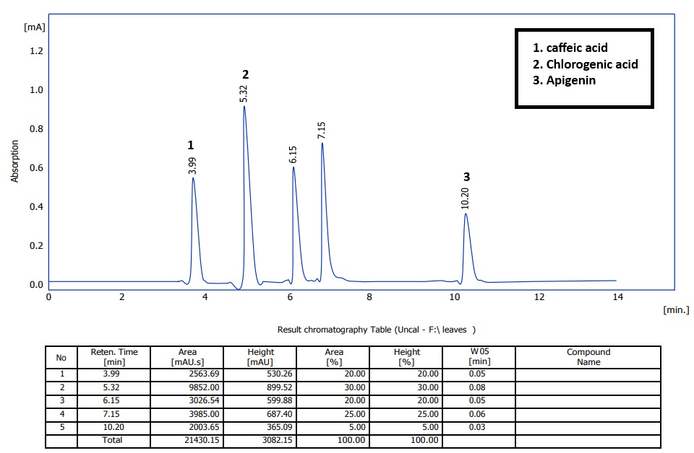
Figure 6. High performance-liquid chromatography chromatogram illustrates of methanolic leaves extract L. leonurus. The x-axis represents retention time (minutes), and the y-axis represents absorbance (mAU) at the detection wavelength.

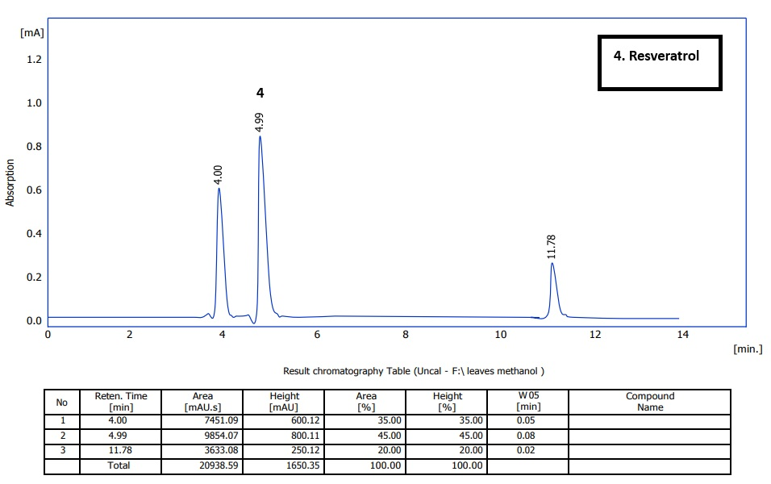

Figure 7. High performance-liquid chromatography chromatogram illustrates of methanolic leaves extract L. leonurus extract under modified condition. The x-axis represents retention time (minutes), and the y-axis represents absorbance (mAU) at the detection wavelength.

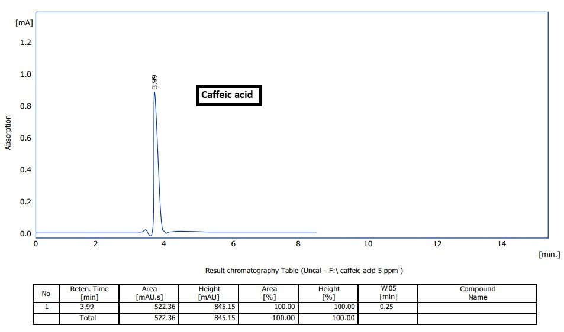

Figure 8. High performance-liquid chromatography chromatogram of std caffeic acid. The x-axis represents retention time (minutes), and the y-axis represents absorbance (mAU) at the detection wavelength.

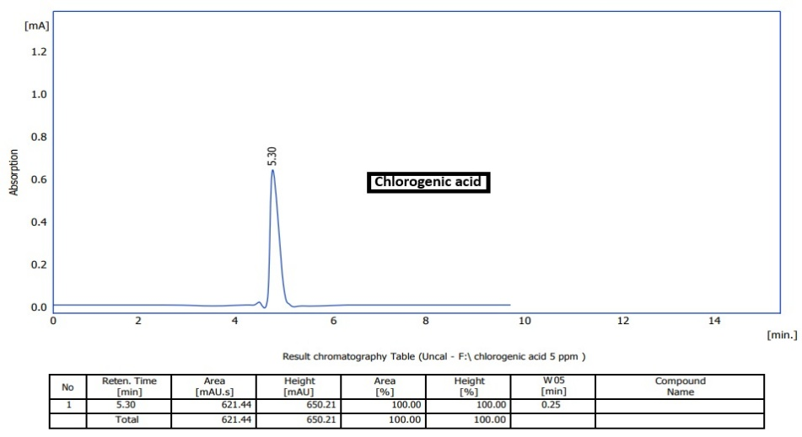

Figure 9. High performance-liquid chromatography chromatogram of std chlorogenic acid. The x-axis represents retention time (minutes), and the y-axis represents absorbance (mAU) at the detection wavelength.
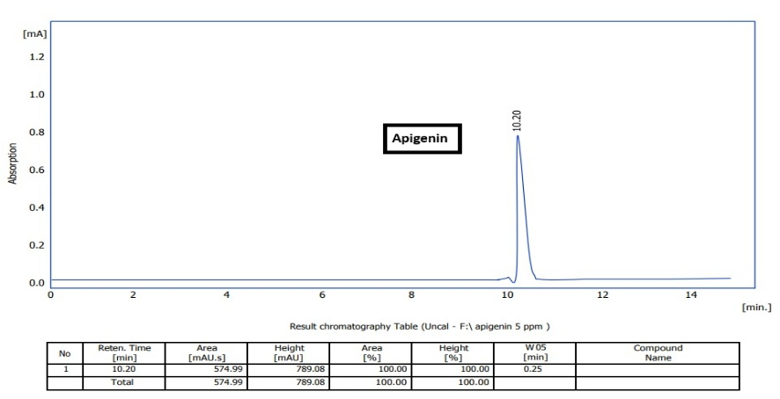

Figure 10. High performance-liquid chromatography chromatogram of std apigenin. The x-axis represents retention time (minutes), and the y-axis represents absorbance (mAU) at the detection wavelength.

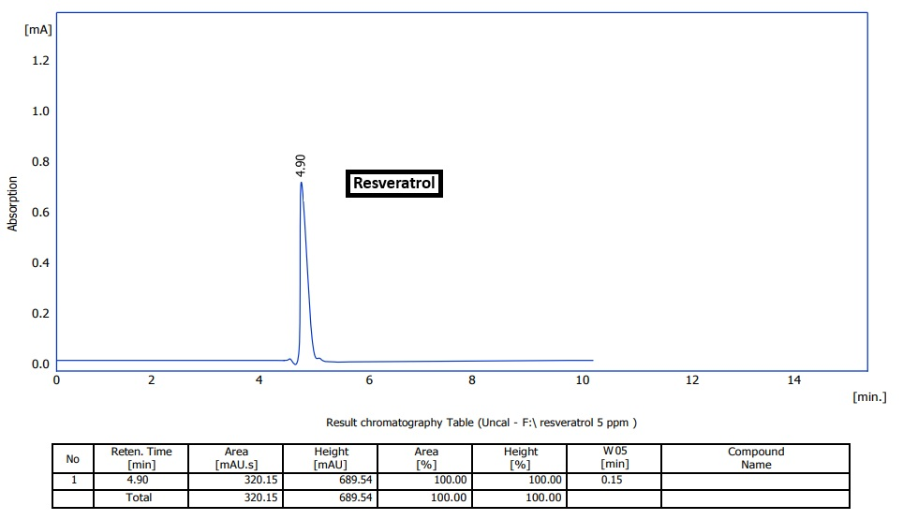

Figure 11. High performance-liquid chromatography chromatogram of std resveratrol. The x-axis represents retention time (minutes), and the y-axis represents absorbance (mAU) at the detection wavelength.

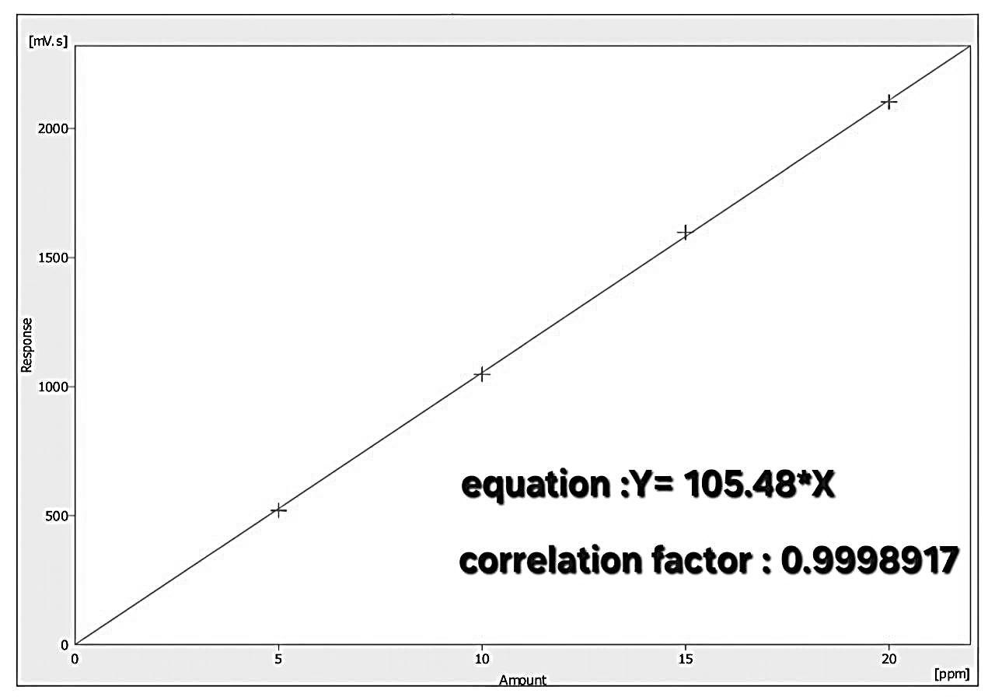

Figure 12. High performance-liquid chromatography calibration plot of caffeic acid. The plot shows a linear relationship between the concentration (Amount, ppm) and the peak area (Response, mVs). The linear regression equation is Y = 105.48 \times X, with a correlation factor of 0.9998917.

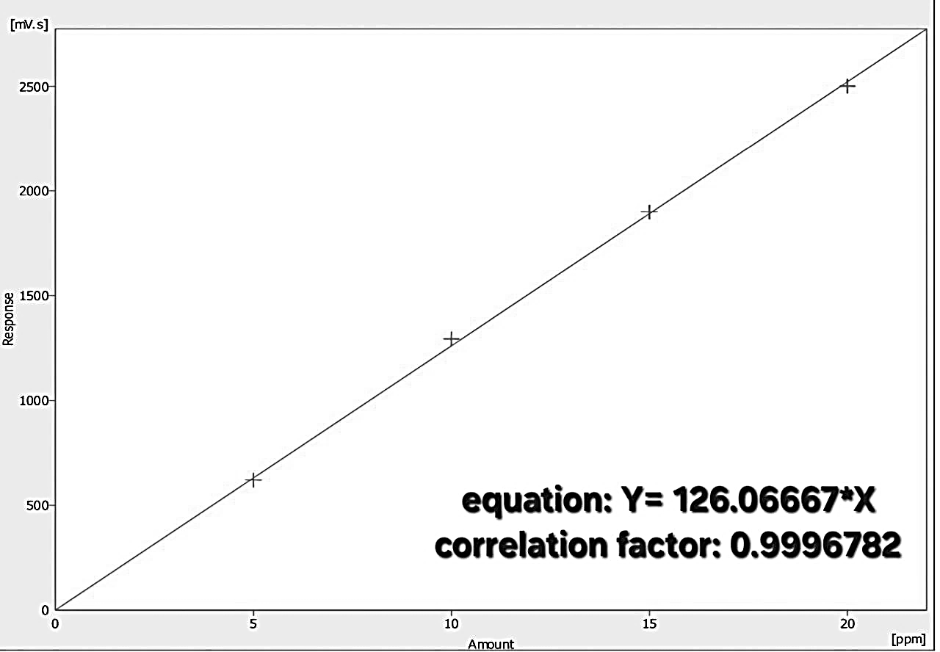

Figure 13. High performance-liquid chromatography calibration plot of chlorogenic acid. The plot shows a linear relationship between the concentration (Amount, ppm) and the peak area (Response, mVs). The linear regression equation is Y = 126.06667 \times X, with a correlation factor of 0.9996782.

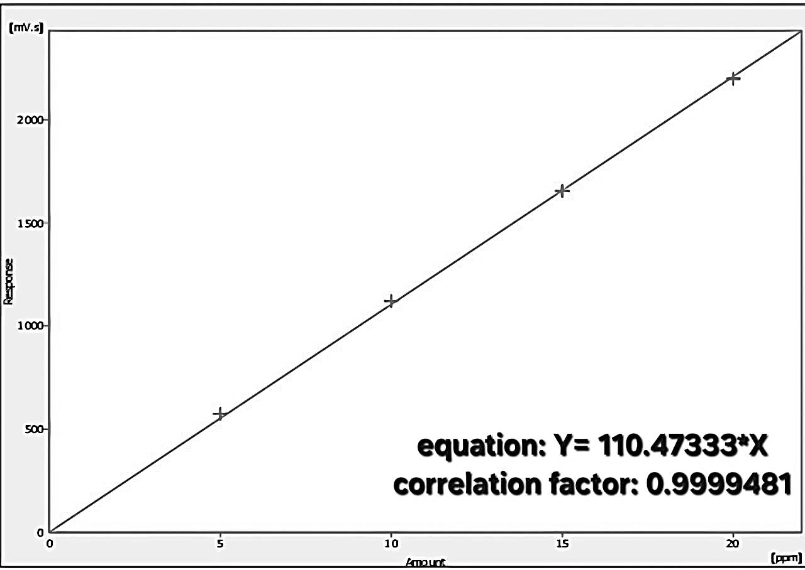

Figure 14. High performance-liquid chromatography calibration plot of apigenin. The plot shows a linear relationship between the concentration (Amount, ppm) and the peak area (Response, mVs). The linear regression equation is Y = 110.47333 \times X, with a correlation factor of 0.9999481.

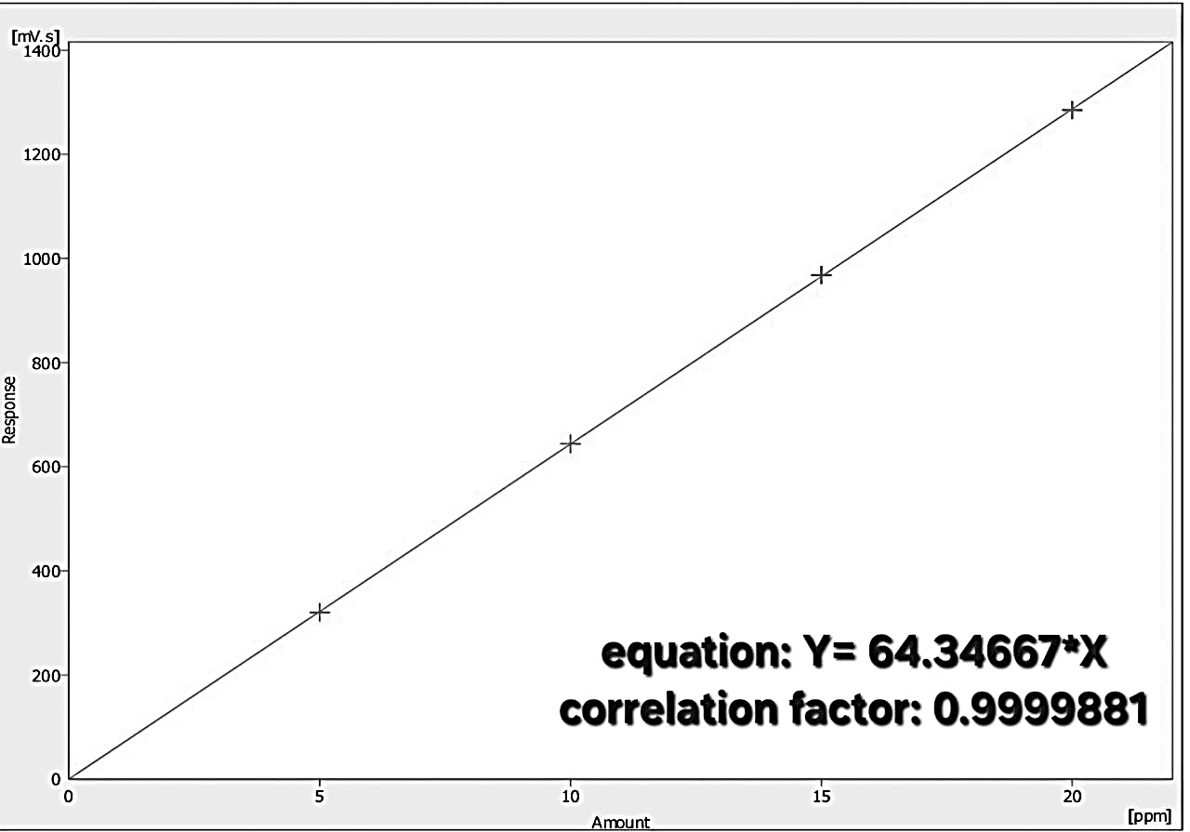

Figure 15. High performance-liquid chromatography calibration plot of resveratrol. The plot shows a linear relationship between the concentration (Amount, ppm) and the peak area (Response, mVs). The linear regression equation is Y = 64.34667 \times X, with a correlation factor of 0.9999881.

The methanolic extract of L. Leonurus leaves exhibited strong cytotoxicity, with an IC50 value of 93.22 µg/mL, and notable antiangiogenic potential, with complete inhibition of angiogenesis at 500 mg/mL. These results align with the previous studies on L. leonurus, where extracts have shown anti-inflammatory and antioxidant activities attributed to similar phytochemicals ^{(2,12)}. For instance, Tonisi et al. ⁽²⁾ reported cytotoxic effects of L. leonurus against other cancer cell lines, with IC50 values ranging from 100-200 µg/mL, slightly higher than our findings, possibly due to differences in extraction methods or plant origin. Comparatively, other Leonotis species, such as L. ocymifolia, have demonstrated antimicrobial and anti-inflammatory properties ⁽²⁸⁾, but limited data exist on their antiangiogenic effects. In the context of ovarian cancer, plant extracts like those from Curcuma longa (turmeric) have shown IC50 values around 50-100 µg/mL against A2780 cells, with antiangiogenic activity via VEGF inhibition ^{(12,13)}, similar to our observed mechanisms. Additionally, extracts from Camellia sinensis (green tea) rich in polyphenols exhibit comparable cytotoxicity (IC50 ~80 µg/mL) and angiogenesis suppression in CAM assays ⁽¹⁶⁾. The benefits are significantly associated with its abundant phenolic acids ⁽²⁹⁾ and flavonoids, especially resveratrol and chlorogenic acid, which are recognized for their anticancer properties via various routes. While resveratrol is a widely studied compound known for its antioxidant and anti-cancer effects across numerous plant sources (e.g., grapes), its novel isolation from L. leonurus represents a unique finding, potentially expanding the known botanical sources for this bioactive molecule and highlighting the plant's untapped potential in resveratrol-related bioactivities. resveratrol has been recognized for its capacity to inhibit tumor angiogenesis. It diminishes intravascular VEGF-A concentrations, obstructs aortic vessel development, and curtails tumor angiogenesis and proliferation in vivo. A key method entails resveratrol's capacity to diminish NF-κB transcription, decreasing VEGF-A expression ⁽³⁰⁾. Conversely Chlorogenic acid has demonstrated efficacy as an anticancer drug by causing apoptosis in neoplastic cells.
The cytotoxic effects are mainly due to its capacity to induce oxidative stress, which alters apoptosis-related proteins (e.g., reduces Bcl-2 expression), activates caspase-3 (resulting in DNA fragmentation), and prompts the liberate of cytochrome c from mitochondria, indicating an obligation to apoptosis ⁽³¹⁾. The apigenin found in the methanolic extract of L. leonurus augments its antiangiogenic and anticancer properties. Apigenin is an extensively studied flavonoid recognized for its ability to impede tumor angiogenesis by affecting critical molecular pathways ⁽³²⁾. Apigenin has been demonstrated to decrease the expression of HIF-1α (hypoxia-inducible factor 1-alpha) and VEGF (vascular endothelial growth factor) in several cancer cells under both normoxic (normal oxygen) and hypoxic (low oxygen) circumstances. Caffeic acid displays anti-cancer activities by selectively reducing MMP-9 activity and transcription, that lead to diminished the cytotoxicity and antiangiogenic activity. It Assists tumor shrinkage and inhibits metastasis without substantial cellular damage ⁽³³⁾. The presence of caffeic acid in L. leonurus extract and other phytoconstituents such as chlorogenic acid, resveratrol, and apigenin, enhances the medicinal value of the extract. These compounds work to gather in synergism to target many processes involved in cancer progression, including angiogenesis, programmed cell death, and metastasis.
A limitation of the current study is that while the CAM assay provides an excellent in vivo model for screening, it is not a full mammalian system. Therefore, the antiangiogenic and cytotoxic findings require further confirmation through mammalian in vivo models. Future research should focus on dose-response studies in a mammalian ovarian cancer model, investigation of specific molecular targets (e.g., VEGF receptor pathways), and toxicity assessments on normal human cell lines to evaluate the therapeutic safety profile of the extract.

Conclusion
In conclusion, this study reveals that the methanolic leaf extract of L. leonurus possesses substantial antiangiogenic and cytotoxic capabilities, positioning it as a viable candidate for natural anticancer therapeutics. A pivotal discovery is the first-time identification of resveratrol in this plant species, complementing the presence of other key polyphenolic compounds known for their roles in suppressing angiogenesis and inducing apoptosis. These findings not only expand the known phytochemical profile of L. leonurus but also underscore its potential to contribute to innovative strategies for managing ovarian cancer, thereby warranting advanced mechanistic studies and clinical evaluations to harness its bioactive components for drug development.
Acknowledgment
We would like to express our deepest appreciation to the College of Pharmacy at the University of Baghdad for providing the essential resources and support that made this research possible.
Conflicts of Interest
The authors do not have any conflict of interest to declare.
Funding
Self-funding
Ethics Statements
The study was conducted in agreement with ethical standard. The approval was granted under license number REC022416R on October 13, 2024.
Author Contribution
AL Shamma D A duties were designing the research context and strategies, supervising the experimental protocols, and contributing to filtering the methodology. Dawood E B was responsible for the extraction process, data analysis and collection, and manuscript writing.
References
- Ibrahem NM, Kadhim EJ, Mutlag SH. Isolation of Catchin and Epigallocatchin From Iraqi Rhus coriaria by Preparative High-Performance Liquid Chromatography (PHPLC). Iraqi J Pharm Sci. 2022;31(2):271-82.
- ​Tonisi S, Okaiyeto K, Hoppe H, Mabinya LV, Nwodo UU, Okoh AI. Chemical constituents, antioxidant and cytotoxicity properties of Leonotis leonurus used in the folklore management of neurological disorders in the Eastern Cape, South Africa. 3 Biotech. 2020;10:1-4.
- ​Mahato RK, Mahato G. Traditional Use of Medicinal Plants against ENT Diseases by the Tribals of Purulia District, West Bengal, India. Pharmacognosy Res. 2023;15(4).
- ​Etsassala NG, Hussein AA, Nchu F. Potential application of some lamiaceae species in the management of diabetes. Plants. 2021;10(2):279.
- ​Ziyodovna AN, Qizi BG. An Analysis of a Half-Century Scientific Papers on Leonurus L. Genus Is Studied In The World: A Review of Papers from The Scopus Database Published In English For The Period of 1968–2023. Eur Sci Rev. 2024;(3-4):3-12.
- ​Cornelius SF, Van Wyk BE. An updated inventory of medicinal and ritual plants of southern Africa. J Ethnopharmacol. 2024;332:118361.
- ​Mazimba O. Leonotis leonurus: A herbal medicine review. J. Pharmacogn. Phytochem. 2015;3:74-72.
- ​Nsuala B, Kamatou G, Enslin G. Chapter 14 - Leonotis leonurus. In: The South African Herbal Pharmacopoeia. Academic Press; 2023. p. 305-20.
- ​Obikeze K, Sasi AA, Raji I. In-silico and in-vivo evaluation of the Cardiovascular effects of five Leonotis leonurus diterpenes. Sci Afr. 2023;19:e01510.
- ​Jeong JH, Ojha U, Lee YM. Pathological angiogenesis and inflammation in tissues. Arch. Pharmacal. Res. 2021;44(1):1-5.
- ​Liu ZL, Chen HH, Zheng LL, Sun LP, Shi L. Angiogenic signaling pathways and anti-angiogenic therapy for cancer. Signal Transduct Target Ther. 2023;8(1):198.
- Abdullah NA, Md Hashim NF, Ammar A, Muhamad Zakuan N. An insight into the anti-angiogenic and anti-metastatic effects of oridonin: current knowledge and future potential. Molecules. 2021;26(4):775.
- ​Najmi A, Javed SA, Al Bratty M, Alhazmi HA. Modern approaches in the discovery and development of plant-based natural products and their analogues as potential therapeutic agents. Molecules. 2022;27(2):349.
- ​Dhayer M, Jordao A, Dekiouk S, Cleret D, Germain N, Marchetti P. Implementing Chicken Chorioallantoic Membrane (CAM) Assays for Validating Biomaterials in Tissue Engineering: Rationale and Methods. J Biomed Mater Res B Appl Biomater. 2024;112(11):e35496.
- ​Vimalraj S, Renugaa S, Dhanasekaran A. Chick embryo chorioallantoic membrane: a biomaterial testing platform for tissue engineering applications. Process Biochem. 2023;124:81-91.
- ​Mapanao AK, Che PP, Sarogni P, Sminia P, Giovannetti E, Voliani V. Tumor grafted–chick chorioallantoic membrane as an alternative model for biological cancer research and conventional/nanomaterial-based theranostics evaluation. Expert Opin Drug Metab Toxicol. 2021;17(8):947-68.
- ​Autor E, Cornejo A, Bimbela F, Maisterra M, Gandía LM, Martínez-Merino V. Extraction of phenolic compounds from Populus Salicaceae bark. Biomolecules. 2022;12(4):539.
- ​Shah SM, Abdul-Jalil TZ. Qualitative and quantitative estimation or chemical constituents from leaves and roots of Iraqi Agave attenuata by GC-MS and RP-HPLC (Conference Paper). Iraqi J Pharm Sci. 2022;31(Suppl.):75-85.
- ​Lokman NA, Elder AS, Ricciardelli C, Oehler MK. Chick chorioallantoic membrane (CAM) assay as an in vivo model to study the effect of newly identified molecules on ovarian cancer invasion and metastasis. Int J Mol Sci. 2012;13(8):9959-70.
- ​Wojtowicz K, Nowicki M. The characterization of the sensitive ovarian cancer cell lines A2780 and W1 in response to ovarian CAFs. Biochem Biophys Res Commun. 2023;662:1-7.
- ​Alawsi DF, Alshammari AM, Majeed MF. The cytotoxic effect of hydro-alcoholic extract of Sanguisorba minor and its fractions on human breast cancer cell line (MCF-7). Iraqi J Pharm Sci. 2022;31(2):168-74.
- Jassim SA, Hanoosh ZW, Abbass AA. Evaluation of the cytotoxic activity of the crude extract and semi-purified n-butanol fraction of Punica granatum peels using MTT assay. Al-Mustansiriyah J Pharm Sci. 2018;18(3):28-36.
- ​Hanoosh ZW, Abbass AA, Jassim SA. Anti-angiogenic effect of n-butanol fraction of pomegranate Punica granatum peels extract in chicken chorioallantoic membrane model. Al-Mustansiriyah J Pharm Sci. 2018;18(3):37-43.
- ​Najim WS, Al-Mizban HM. The cytotoxic effect of hydro-alcoholic extract of Sanguisorba minor and its fractions on human breast cancer cell line (MCF-7). Iraqi J Pharm Sci. 2022;31(2):168-74.
- ​Kadhim EJ, Ibrahem NM, Mutlag SH. Qualitative and Quantitative Analysis of the Phenolic Compounds of Iraqi Rhus coriaria by Reverse Phase HPLC. Iraqi J Pharm Sci. 2022;31(2):175-82.
- ​Auda MA, Abdulhussain AH, Al-Asadi H. Qualitative and quantitative analysis of phenolic compounds and flavonoids in methanolic extract of Iraqi Prosopis farcta by RP-HPLC. Iraqi J Pharm Sci. 2022;31(2):30-9.
- ​Al-kufi Z A, Yaseen T A. Qualitative and quantitative analysis of flavonoids and phenolic acids in methanolic extract of the local cultivated Cynara scolymus L. leaves by HPLC. Ibn Al-Haitham J Pure Appl Sci. 2021;34(3):141-53.
- ​Al-Rubaya HKA, Alwan AHM, AL-Attar HBM. Phytochemical analysis and anti-inflammatory activity of Leonotis ocymifolia extract cultivated in Iraq. J Res Pharm. 2023;27(1):164-75.
- ​Alwan AHM, Nami Y, AL-Rubaya HKA. Cytotoxic and apoptotic effects of Leonotis ocymifolia extract on breast cancer cell line (MCF7) in vitro. J Res Pharm. 2023;27(2):492-503.
- ​Zhang J, Liu X, Biyashev D, Wang J, Shi C, Zhao X, et al. Resveratrol inhibits angiogenesis by regulating Wnt/β-catenin and NF-κB signaling pathways. Bioengineering. 2023;10(8):912.
- ​Zang Y, Jin S, Li T, Zhang F, Yu H, Wang C, et al. Chlorogenic acid induces apoptosis of human colorectal cancer cells via the p53 pathway. Int J Mol Sci. 2023;24(3):2333.
- ​Lee YS, Han MK, Lee YM. Apigenin and its analogues as anti-angiogenic agents. Int J Mol Sci. 2022;23(18):10636.
- ​Al-Khafaji KAA. The anti-cancer effect of caffeic acid and ferulic acid extracted from Iraqi Euphorbia hirta on colon cancer cell line (HT-29) in vitro. Iraqi J Pharm Sci. 2024;33(1):136-47.

استكشاف النشاط المضاد لتولد الأوعية داخل الجسم عن طريق فحص CAM والتأثيرات السامة للخلايا في المختبر لمستخلص أوراق الميثانول من نبات Leonotis leonurus المزروع في العراق
ضد خلايا سرطان المبيض البشرية A2780
إيلاف باسم داود^{*،1} و ضحى الشماع¹
¹قسم العقاقير والنباتات الطبية، كلية الصيدلة، جامعة بغداد، العراق
الخلاصة
استهدفت هذه الدراسة تقييم النشاط المضاد لتكوّن الأوعية الدموية (داخل الجسم الحي) والتأثيرات السامة للخلايا (في المختبر) لمستخلص أوراق الميثانول من نبات (Leonotis leonurus) (من الفصيلة الشفوية - Lamiaceae)، المعروف تجاريًا في الطب التقليدي باسم "الداغا البرية" أو "أذن الأسد"، ضد خلايا سرطان المبيض البشري 2780A. تُعزى الإمكانات العلاجية لهذا النبات إلى مركباته الكيميائية النباتية، وهي مستقلبات ثانوية توفر حماية ضد العدوى والضغوط البيئية. تم تقييم النشاط المضاد لتكوّن الأوعية الدموية باستخدام اختبار الغشاء المشيمي الألانتوي (CAM)، حيث طُبِّق المستخلص بتركيز ٥٠٠ مجم/مل، وتم رصد تثبيط نمو الأوعية الدموية بعد ٤٨ ساعة. كما جرى تقييم السمية الخلوية عبر اختبار MTT على خلايا 2780A التي عُولجت بتركيزات للمستخلص تراوحت بين ٣١.٢٥ و١٠٠٠ ميكروغرام/مل لمدة ٧٢ ساعة، وتم قياس بقاء الخلايا بواسطة الكثافة الضوئية عند ٤٩٢ نانومتر. تم إجراء تحليل كيميائي نباتي باستخدام كروماتوغرافيا سائلة عالية الأداء عكسية الطور (RP-HPLC) مع معايير للتحديد والتحديد الكمي. تم تحديد الأهمية الإحصائية بواسطة تحليل التباين الأحادي المتباين (ANOVA) متبوعًا باختبار المقارنات المتعددة لتوك. (p < 0.05) اظهر اختبار CAM تثبيطًا بنسبة ١٠٠٪ لنمو الأوعية الدموية عند تركيز ٥٠٠ مجم/مل مقارنةً بالمجموعات الضابطة. وكشف اختبار MTT عن سمية خلوية تعتمد على الجرعة، بقيمة IC٥٠ بلغت ٩٣.٢٢ ميكروغرام/مل، وتراوحت نسب السمية الخلوية من ١٤٪ عند تركيز ٣١.٢٥ ميكروغرام/مل إلى ٦٩٪ عند تركيز ١٠٠٠ ميكروغرام/مل؛ لوحظ انخفاض كبير في الكثافة الضوئية (p < 0.05) عند جميع التركيزات. حدد RP-HPLC مستويات عالية من الأحماض الفينولية والستيلبين والفلافونويد، بما في ذلك الريسفيراترول (٦٦٥.٤ جزء في المليون؛ اكتشاف جديد في هذا النبات)، وحمض الكلوروجينيك (٣٤٢.٧جزء في المليون)، والأبيجينين (٢٨٠.٢جزء في المليون)، وحمض الكافيين (١٠٦.١١جزء في المليون)، والتي ترتبط بقمع الأوعية الدموية وتحفيز موت الخلايا المبرمج. تضع هذه النتائج L. leonurus كمصدر طبيعي واعد للمركبات النشطة بيولوجيًا ذات الخصائص المضادة لتكوين الأوعية الدموية والسامة للخلايا، مما يستدعي إجراء مزيد من الأبحاث لتطوير عقاقير مضادة للسرطان.
الكلمات المفتاحية: Leonotis leonurus؛ نشاط مضاد لتكون الأوعية الدموية؛ سمية خلوية؛ اختبار CAM؛ سرطان المبيض؛ مركبات فينولية؛ ريسفيراترول؛ حمض الكلوروجينيك.

